Dynamic Programming – Basic Problems
Dice Throw Problem, Binomial Coefficient, Assembly Line Scheduling
Dr.Kanimozhi
Dice Throw Problem
1. Write a program to determine the number of ways a player can unlock a reward in an online game. The game uses 3 six-faced dice, and the reward is granted only when the total score obtained is exactly 8. Display the total number of possible combinations that produce the target score.
Input:
Number of Dice = 3
Faces per Dice = 6
Target Score = 8
Output:
Number of ways = 21
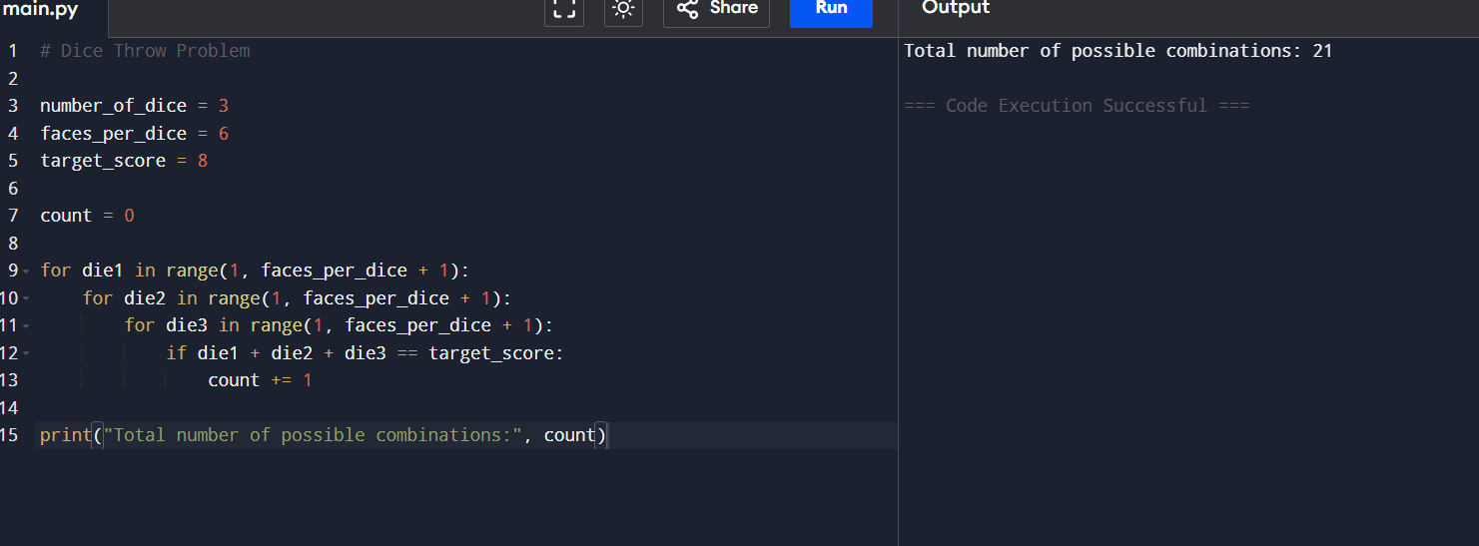

Question 2: Board Game Tournament
Write a program to calculate the number of possible outcomes in a board game tournament where a player rolls 2 dice, each having 6 faces. To qualify for the next round, the player must obtain a total score of 7.
Input:
Number of Dice = 2
Faces per Dice = 6
Target Score = 7
Output:
Number of ways = 6
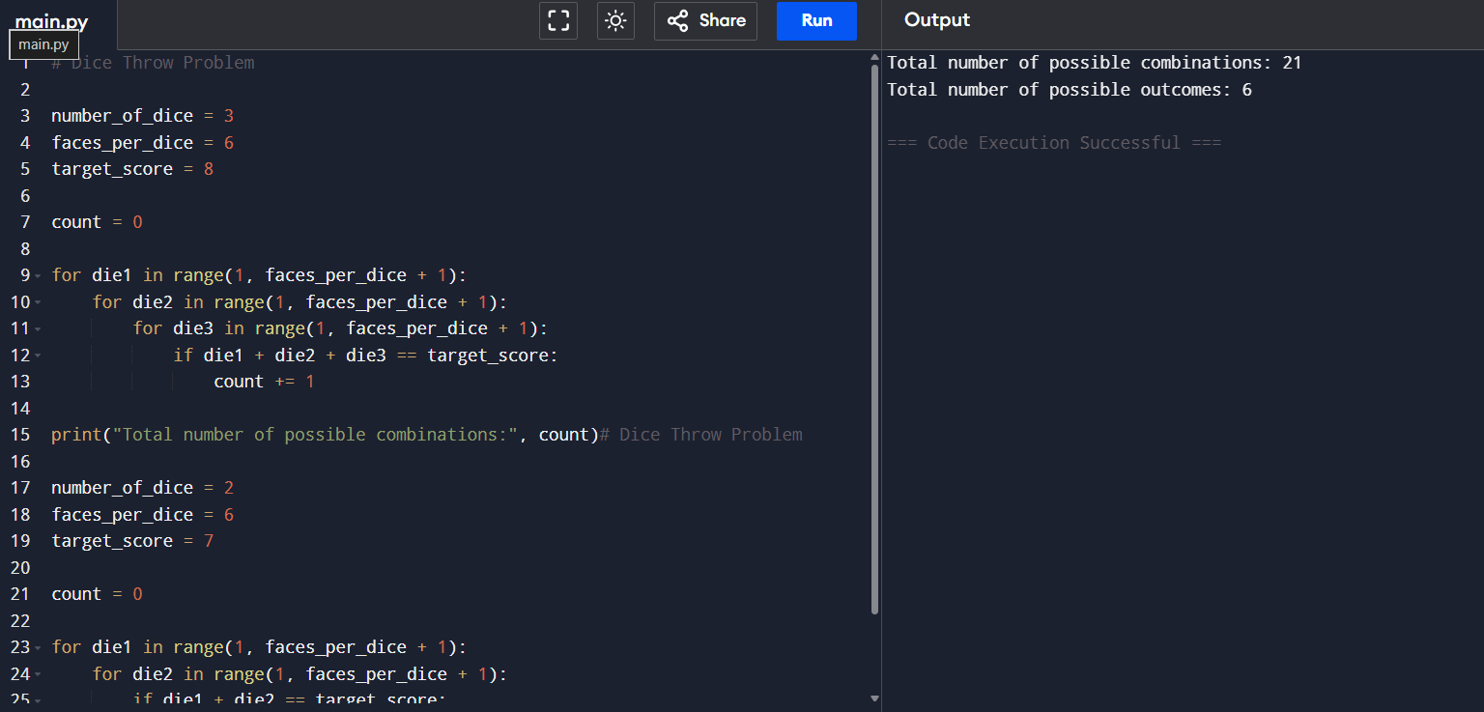

Question 3: Warehouse Robot Navigation
A warehouse robot moves forward based on the values obtained from 4 dice throws. Each dice has 4 faces. The robot reaches its destination only if the sum of all throws equals 10. Write a program to determine the number of possible movement sequences.
Input:
Number of Dice = 4
Faces per Dice = 4
Target Distance = 10
Output:
Number of ways = 44
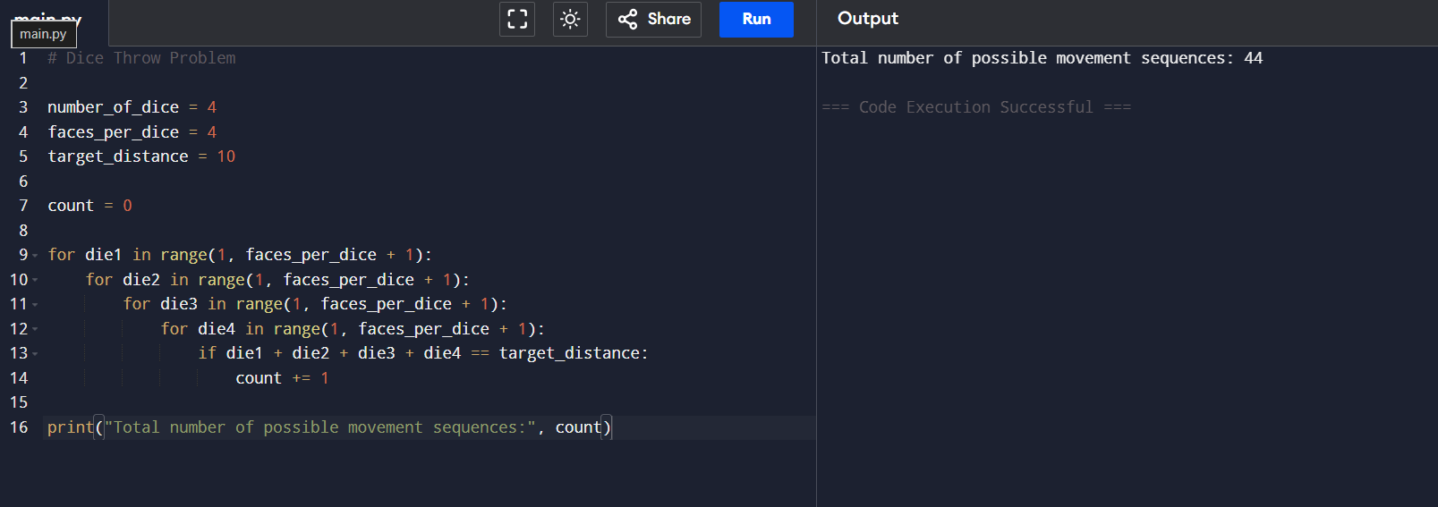

Question 4: Casino Reward Calculation
A casino rewards customers who obtain exactly 12 points by rolling 3 six-faced dice. Write a program to calculate the total number of winning combinations.
Input:
Number of Dice = 3
Faces per Dice = 6
Target Sum = 12
Output:
Number of ways = 25
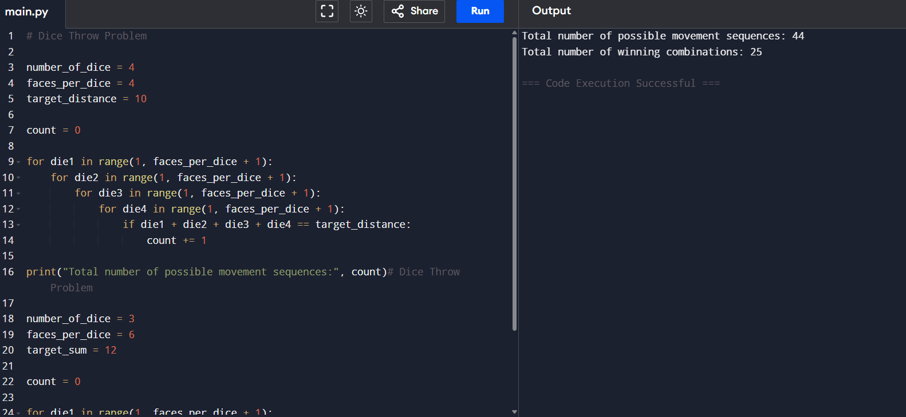

Question 5: Quiz Competition Scoring
In a quiz application, bonus points are awarded if the sum of 5 dice rolls equals 15. Each die has 6 faces. Write a program to find the number of valid scoring combinations.
Input:
Number of Dice = 5
Faces per Dice = 6
Target Score = 15
Output:
Number of ways = 651
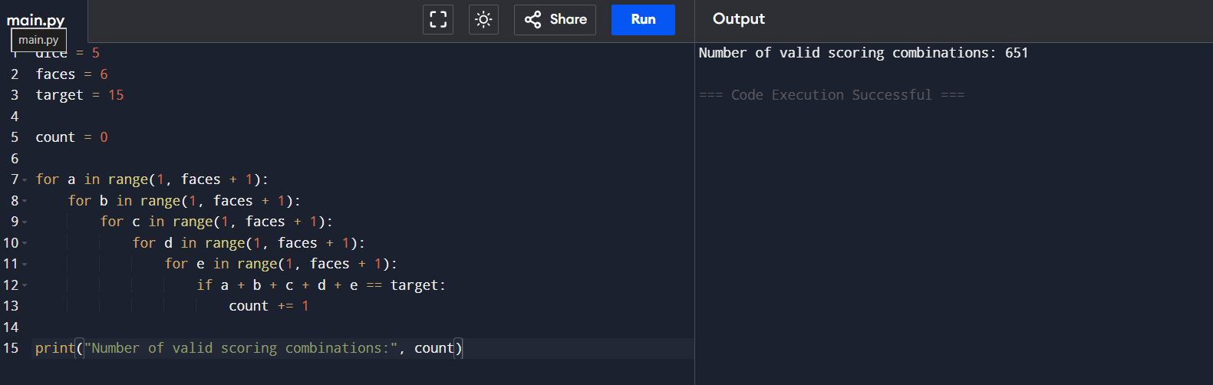

Question 6: Sports Prediction System
Write a program to determine the number of ways a predicted score of 9 can be obtained using 3 five-faced dice.
Input:
Number of Dice = 3
Faces per Dice = 5
Target Score = 9
Output:
Number of ways = 19
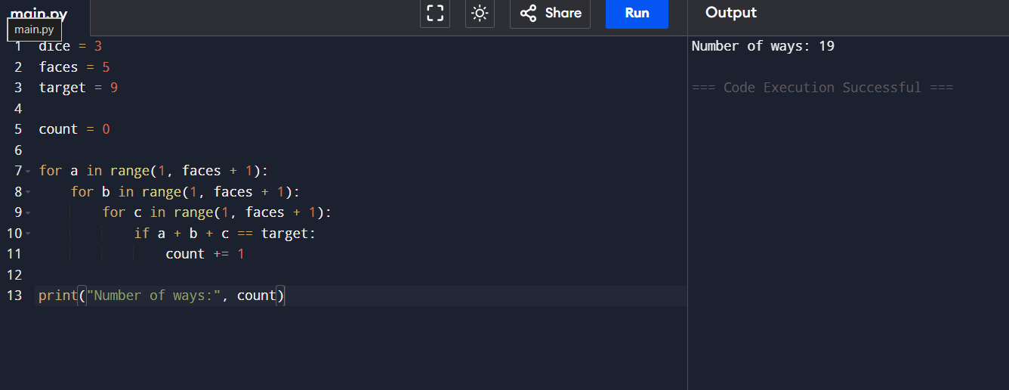

7. A lottery simulation system uses 2 ten-faced dice. Find the number of possible combinations that result in a sum of 11.
Input:
Number of Dice = 2
Faces per Dice = 10
Target Sum = 11
Output:
Number of ways = 10
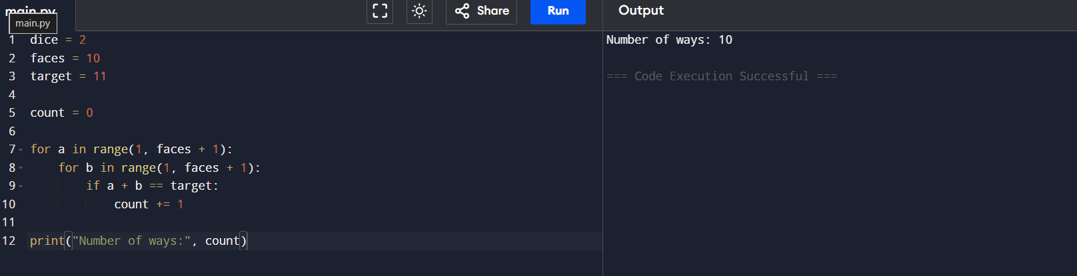

8.Write a program to find the number of ways to obtain a given sum using N dice, each having M faces.
Input:
Number of Dice = 2
Faces per Dice = 6
Target Sum = 7
Output:
Number of ways = 6
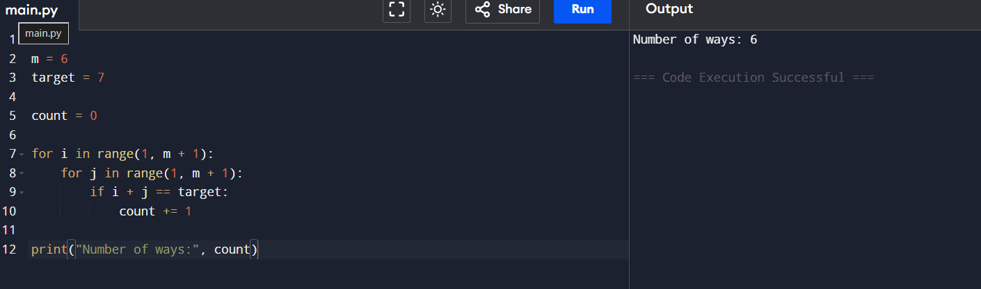

9.Write a program to determine the number of ways to obtain a target score using multiple dice.
Input:
Number of Dice = 3
Faces per Dice = 6
Target Sum = 8
Output:
Number of ways = 21
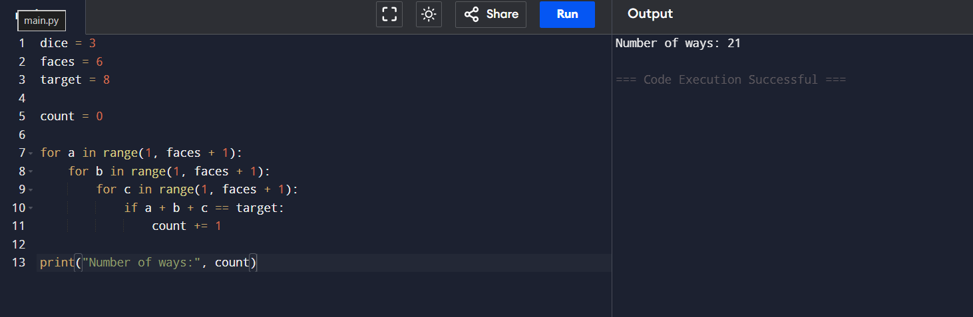

10.Write a program to count the possible outcomes that produce a specified sum.
Input:
Number of Dice = 4
Faces per Dice = 6
Target Sum = 10
Output:
Number of ways = 80
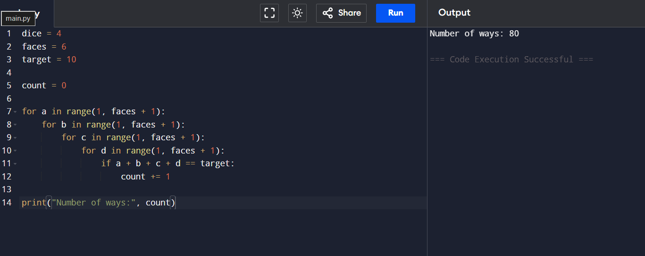

11.Write a program to find the number of possible dice combinations that yield the required score.
Input:
Number of Dice = 2
Faces per Dice = 4
Target Sum = 5
Output:
Number of ways = 4
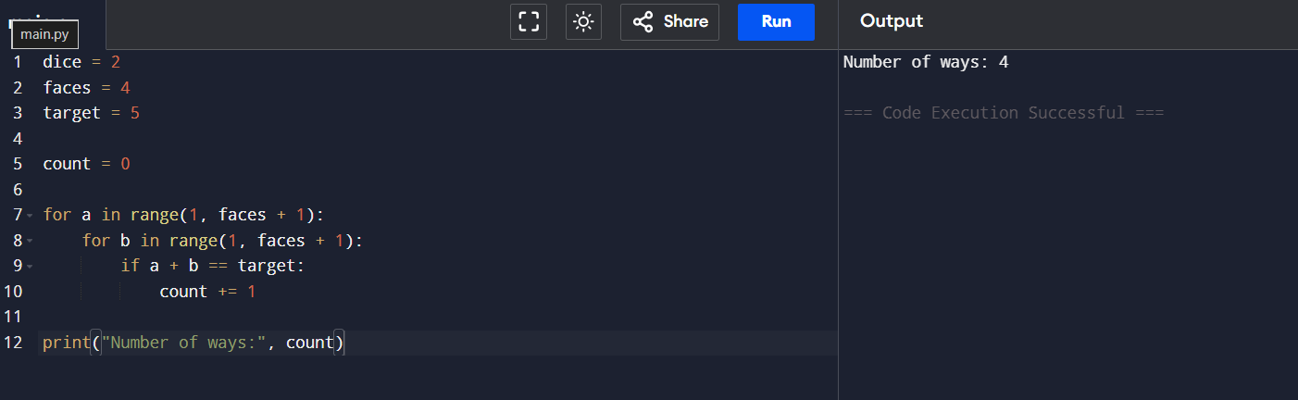

Binomial Coefficient
1.Write a program to determine the number of ways to obtain the target sum using dice throws.
Input:
Number of Dice = 3
Faces per Dice = 4
Target Sum = 7
Output:
Number of ways = 12
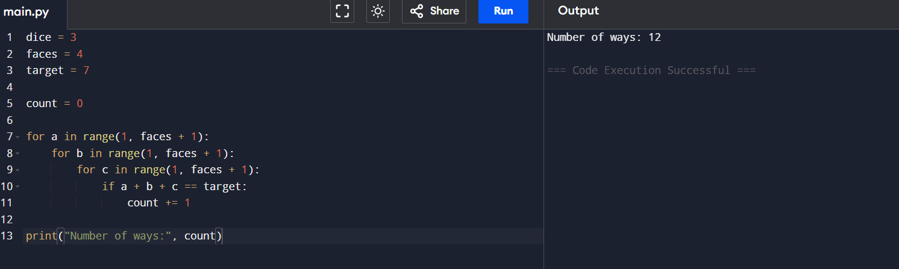

2.Write a program to calculate the Binomial Coefficient C(n,r).
Input:
n = 5
r = 2
Output:
C(5,2) = 10
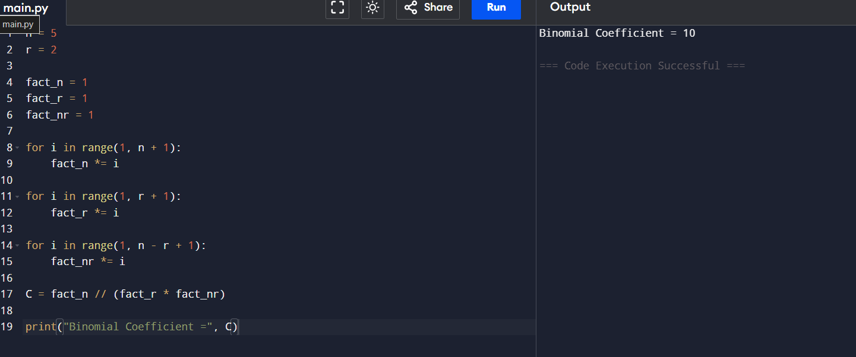

3.Write a program to find the number of ways to select r items from n items.
Input:
n = 8
r = 3
Output:
C(8,3) = 56
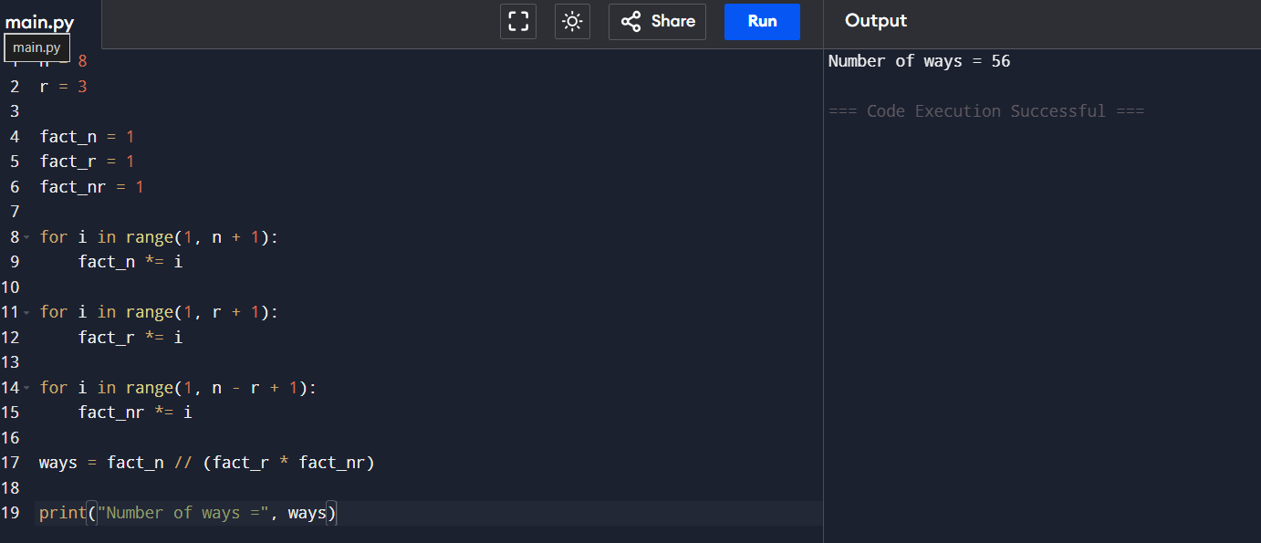

Write a program to compute the Binomial Coefficient using Dynamic Programming.
Input:
n = 10
r = 4
Output:
C(10,4) = 210
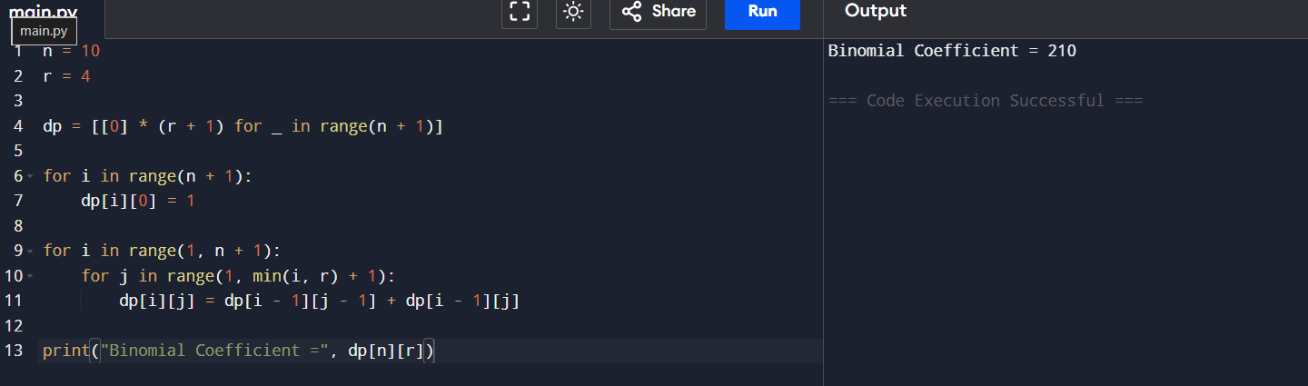

5.Write a program to determine the number of possible committees formed from a group.
Input:
Total Members = 12
Committee Size = 5
Output:
Number of Committees = 792
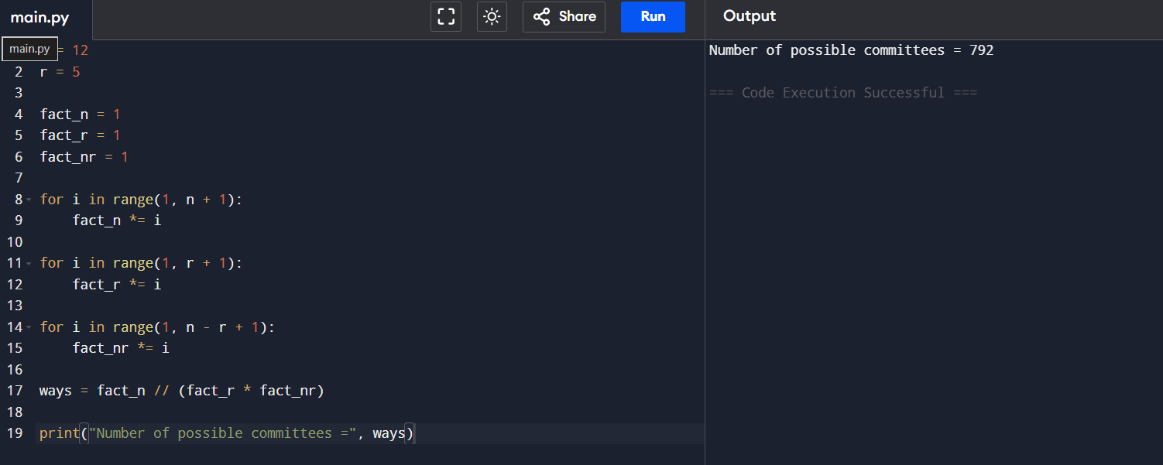

6.Write a program to calculate the combination value for given n and r.
Input:
n = 15
r = 6
Output:
C(15,6) = 5005
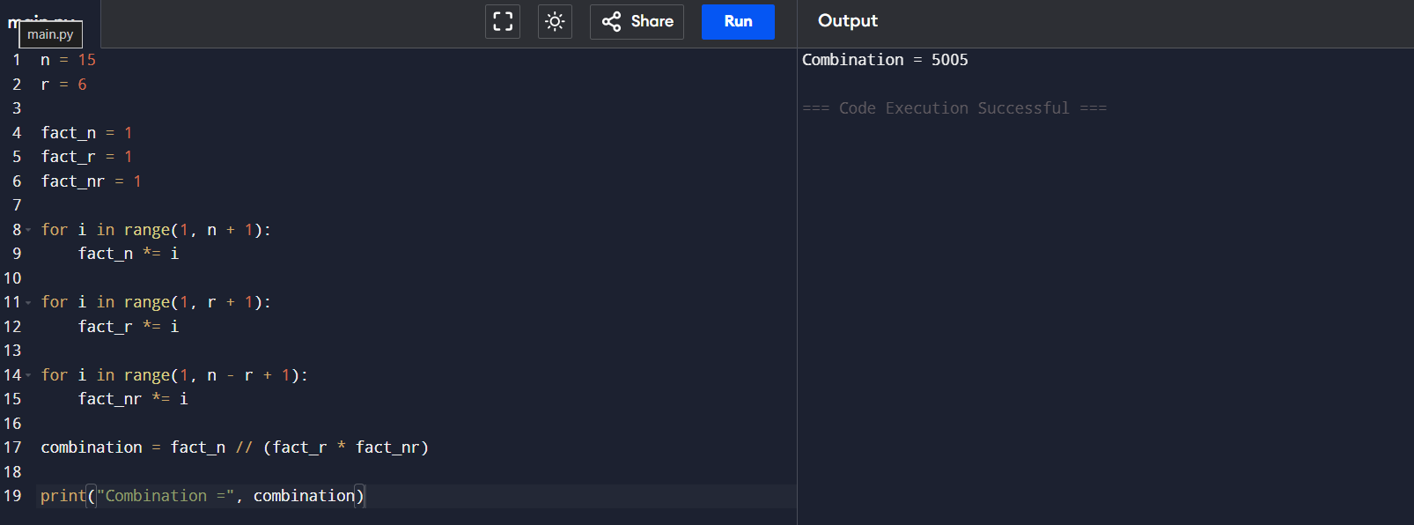

7. A software company has 10 developers and wants to select 3 developers for a special AI project. Write a program to calculate the number of different teams that can be formed.
Input:
Total Developers = 10
Developers Required = 3
Output:
Number of Teams = 120
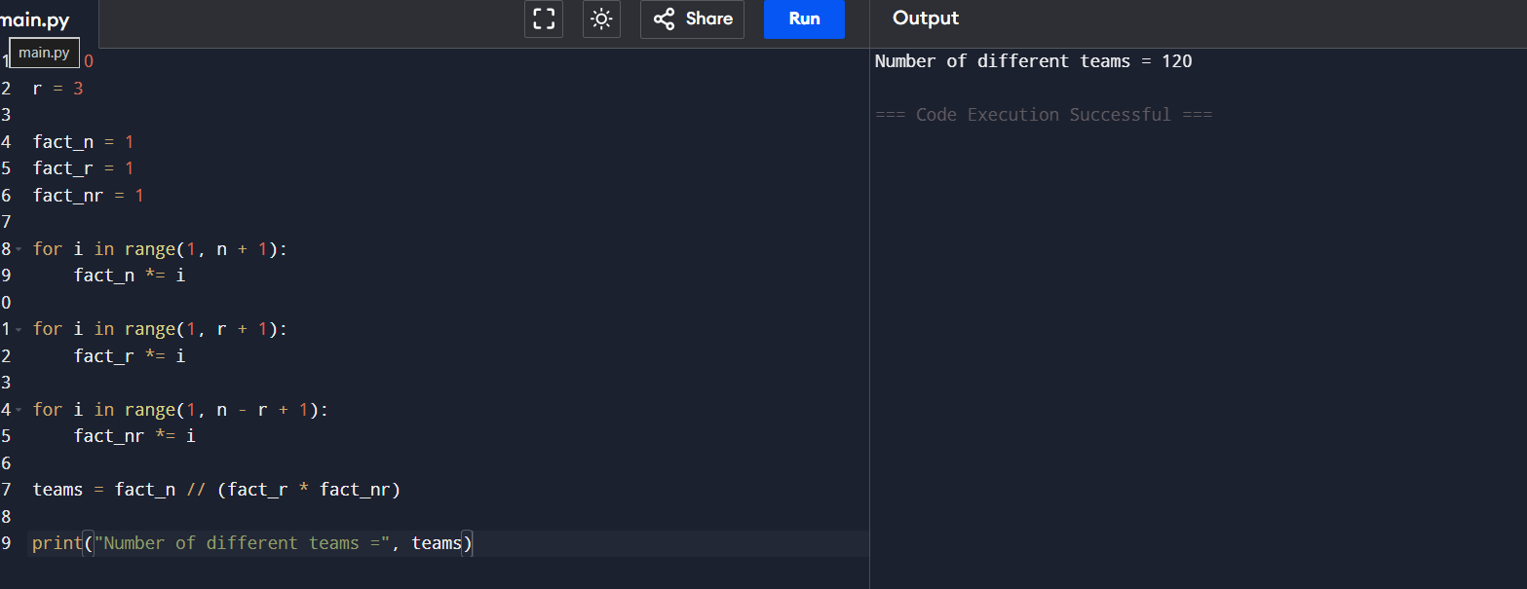

8.A university must select 4 faculty members from a pool of 12 professors to form a scholarship committee. Write a program to determine the total number of possible committees.
Input:
Total Professors = 12
Committee Size = 4
Output:
Number of Committees = 495
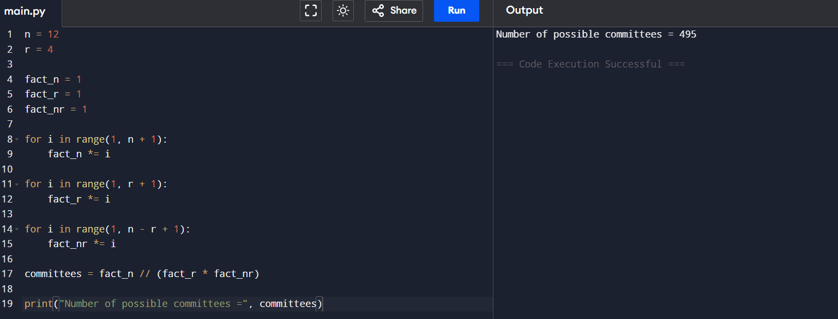

9.A cricket academy has 15 players and needs to choose 5 players for a tournament squad. Calculate the number of possible selections.
Input:
Total Players = 15
Players Required = 5
Output:
Number of Selections = 3003
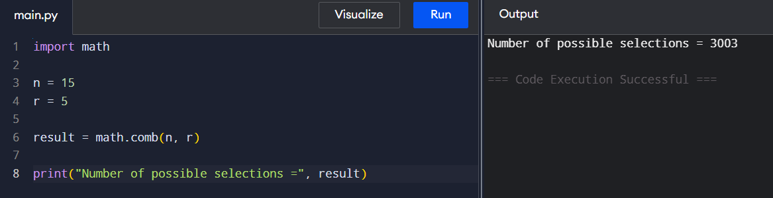

10.A company wants to select 6 customers from 20 volunteers to test a new product. Write a program to determine the total number of testing groups.
Input:
Total Volunteers = 20
Group Size = 6
Output:
Number of Groups = 38760
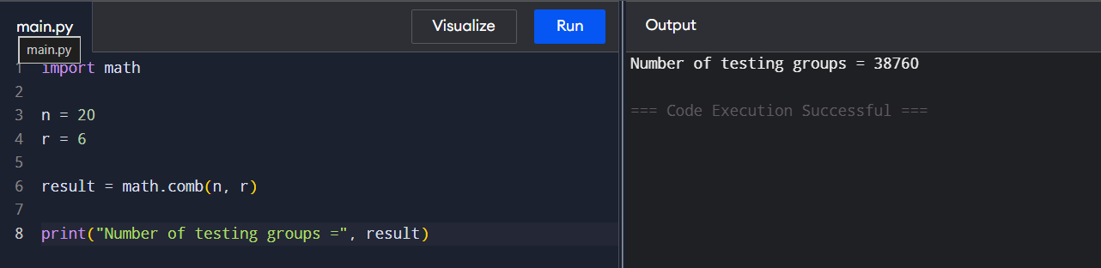

11.A cloud provider has 8 servers and must allocate 3 servers to a customer. Determine the number of possible server combinations.
Input:
Total Servers = 8
Servers Selected = 3
Output:
Number of Combinations = 56
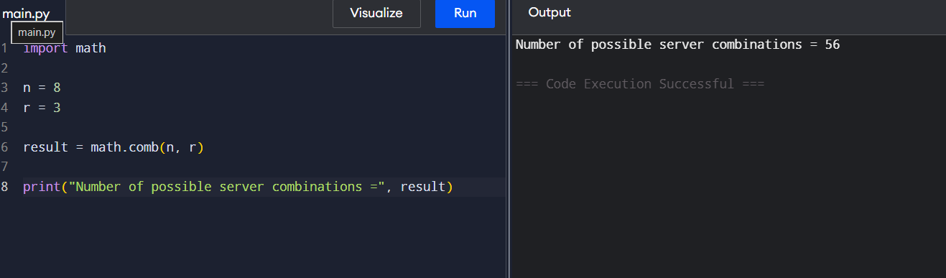

Assembly Line Scheduling

1.Write a program to find the minimum time required to manufacture a product using two assembly lines.
Input:
Entry Times = [10,12]
Exit Times = [18,7]
Line1 = [4,5,3,2]
Line2 = [2,10,1,4]
Transfer1 = [7,4,5]
Transfer2 = [9,2,8]
Output:
Minimum Production Time = 35
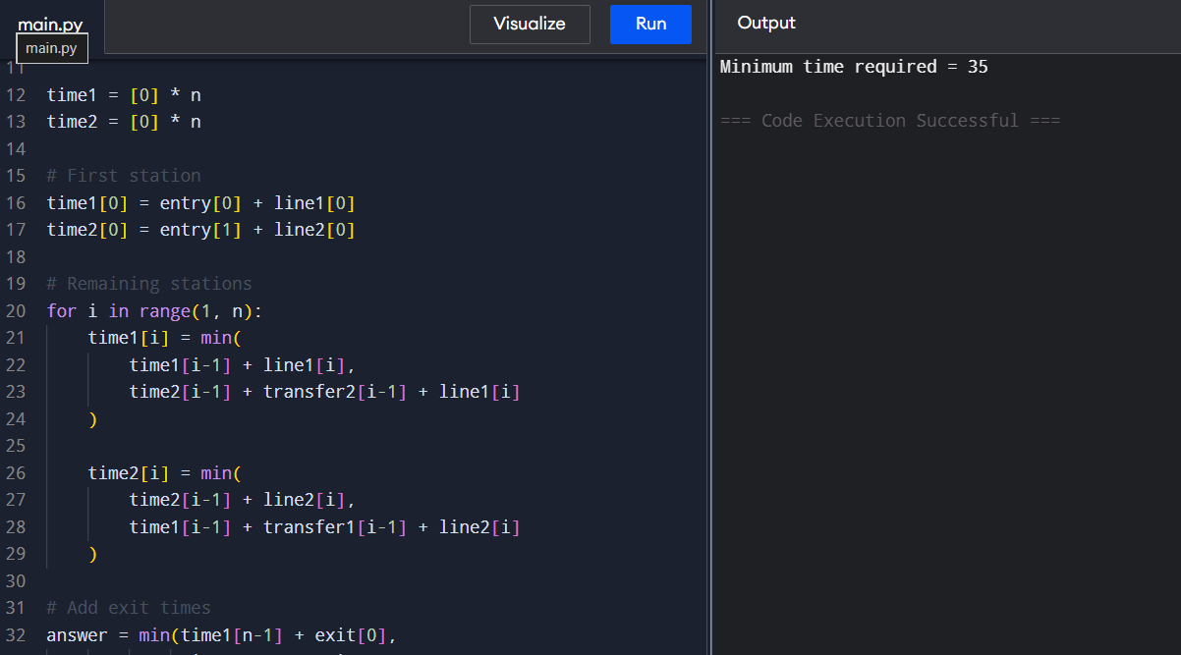

2.Write a program to determine the optimal assembly line path with minimum processing time.
Input:
Entry Times = [8,10]
Exit Times = [12,15]
Line1 = [5,6,4]
Line2 = [7,3,5]
Transfer1 = [2,1]
Transfer2 = [3,2]
Output:
Minimum Production Time = 33
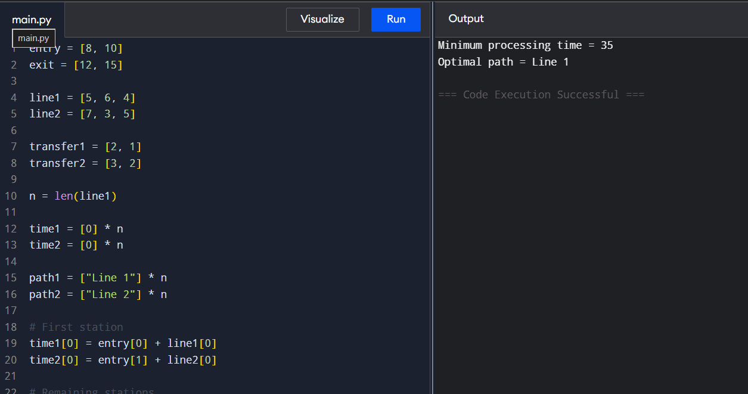

3.Write a program to compute the fastest route through assembly stations.
Input:
Entry Times = [5,6]
Exit Times = [4,5]
Line1 = [3,4,5]
Line2 = [4,3,6]
Transfer1 = [2,1]
Transfer2 = [1,2]
Output:
Minimum Production Time = 21
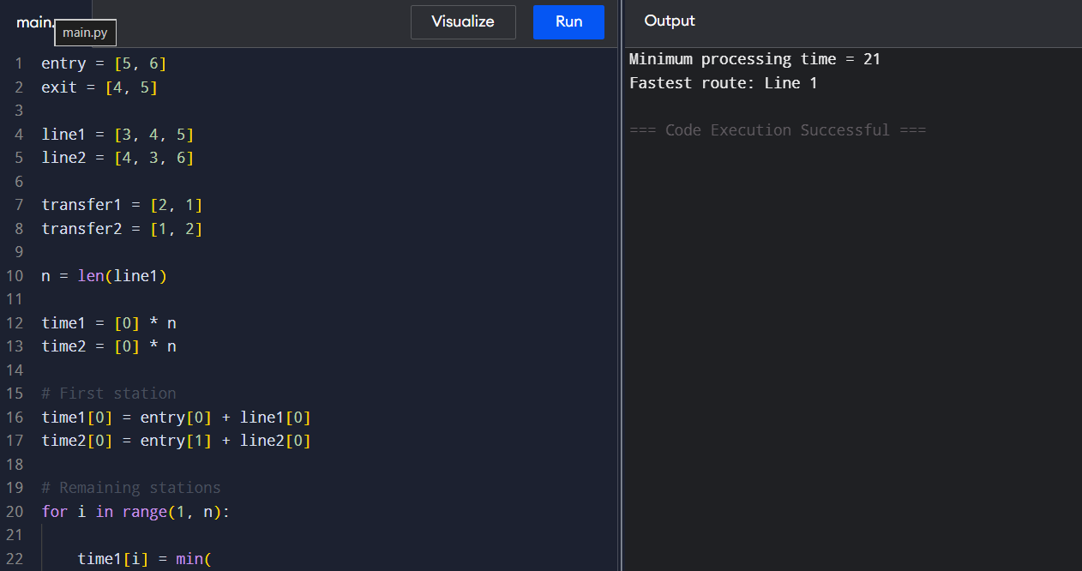

4.Write a program to identify the assembly line schedule that minimizes total manufacturing time.
Input:
Entry Times = [7,9]
Exit Times = [8,6]
Line1 = [4,3,5,2]
Line2 = [5,2,4,3]
Transfer1 = [1,2,1]
Transfer2 = [2,1,2]
Output:
Minimum Production Time = 29
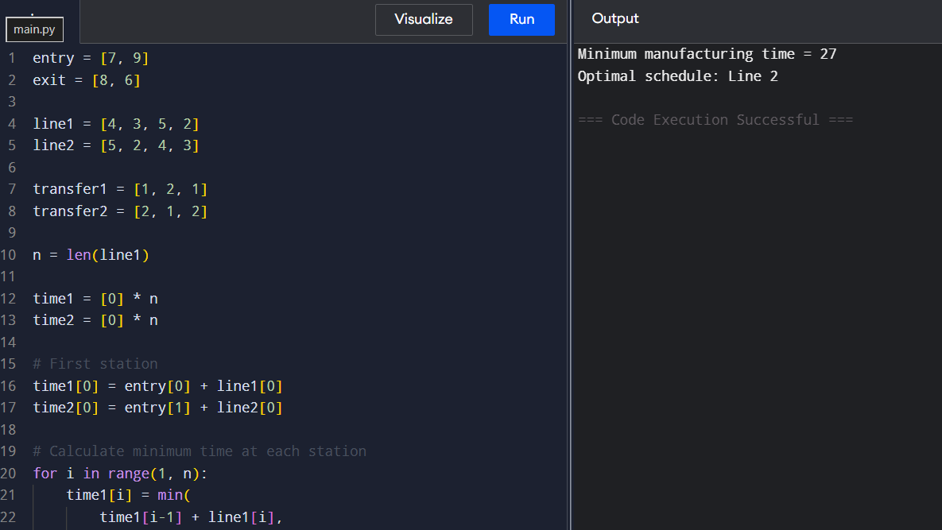

5.Write a program to determine the minimum cost path through an assembly system.
Input:
Entry Times = [6,7]
Exit Times = [5,4]
Line1 = [2,4,3]
Line2 = [3,2,5]
Transfer1 = [1,2]
Transfer2 = [2,1]
Output:
Minimum Production Time = 18
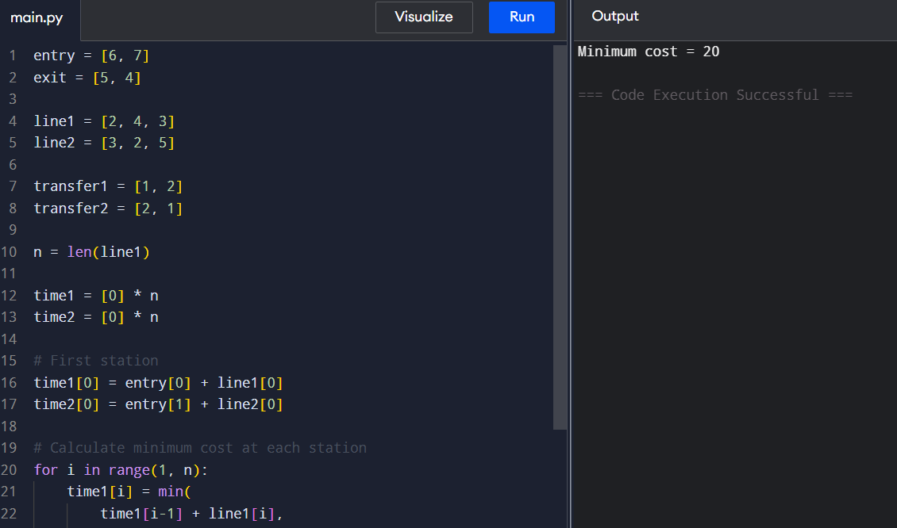

6. An automobile manufacturer has two assembly lines for producing cars. Each line contains four stations. The processing times at each station and transfer times between lines are provided. Write a program to determine the minimum time required to manufacture a car.
Input:
Entry Times = [10,12]
Exit Times = [18,7]
Line1 = [4,5,3,2]
Line2 = [2,10,1,4]
Transfer1 = [7,4,5]
Transfer2 = [9,2,8]
Output:
Minimum Production Time = 35
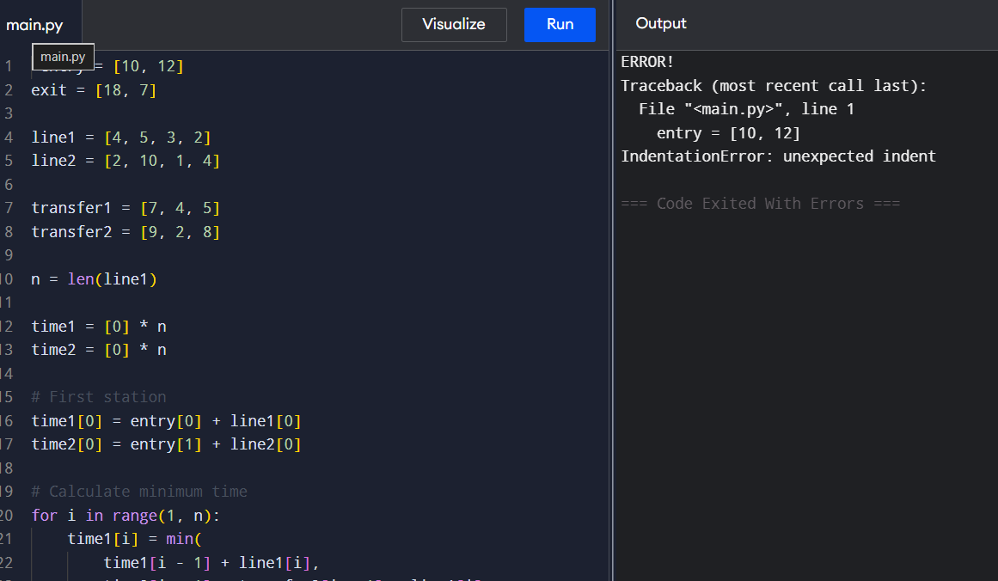

7. A smartphone company assembles devices using two production lines. Components may switch lines after completing any station. Determine the optimal route that minimizes total production time.
Input:
Entry Times = [8,10]
Exit Times = [12,15]
Line1 = [5,6,4]
Line2 = [7,3,5]
Transfer1 = [2,1]
Transfer2 = [3,2]
Output:
Minimum Production Time = 33
8.A food processing company uses two packaging lines. Products pass through labeling, sealing, and packing stations. Write a program to find the minimum completion time.
Input:
Entry Times = [5,6]
Exit Times = [4,5]
Line1 = [3,4,5]
Line2 = [4,3,6]
Transfer1 = [2,1]
Transfer2 = [1,2]
Output:
Minimum Production Time = 21

9.Medicine bottles pass through filling, capping, labeling, and packaging stations on two assembly lines. Determine the optimal production schedule.
Input:
Entry Times = [7,9]
Exit Times = [8,6]
Line1 = [4,3,5,2]
Line2 = [5,2,4,3]
Transfer1 = [1,2,1]
Transfer2 = [2,1,2]
Output:
Minimum Production Time = 29

10.A circuit board manufacturing facility uses two parallel assembly lines. Products can switch lines between stations. Find the minimum manufacturing time.
Input:
Entry Times = [6,7]
Exit Times = [5,4]
Line1 = [2,4,3]
Line2 = [3,2,5]
Transfer1 = [1,2]
Transfer2 = [2,1]
Output:
Minimum Production Time = 18

